**(A typical Specimen of Cover Page & Title Page)**

**TITLE OF PROJECT**

**Capstone Project Proposal**

**Submitted by:**

101917058 Pooja Shah

101917057 Yatishaya Sagar

101903241 Gauranshi Gupta

101917069 Harmohanjeet Kaur

**BE Third Year- COE**

**CPG No. _____**

Under the Mentorship of

Name of Faculty Mentor

Designation

Name of Co-Mentor (if any)

Designation



**Computer Science and Engineering Department**

**Thapar Institute of Engineering and Technology, Patiala**

**MONTH & YEAR**

**TABLE OF CONTENTS**

* Mentor Consent Form <Page No>
* Project Overview <Page No>
* Problem Statement …..
* Need Analysis (1 Page) …..
* Literature Survey (3 Pages) …..
* Objectives
* Methodology
* Project Outcomes & Individual Roles
* Work Plan
* Course Subjects
* References

**Mentor Consent Form**

I hereby agree to be the mentor of the following Capstone Project Team

|  |  |  |
| --- | --- | --- |
| **Project Title:** | | |
| **Roll No** | **Name** | **Signatures** |
|  |  |  |
|  |  |  |
|  |  |  |
|  |  |  |

NAME of Mentor: ……… . . . . . . . . . . . . . . . . . . . . . . . . . . . . . . . . . . .

SIGNATURE of Mentor: . . . . . . . . . . . . . . . . . . . . . . . . . . . . . . . . . . . .

NAME of Co-Mentor(if any): ……… . . . . . . . . . . . . . . . . . . . . . . . . . .

SIGNATURE of Co-Mentor: . . . . . . . . . . . . . . . . . . . . . . . . . . . . . . . . . . . .

**Project Overview**

This project is a mouse simulation system which performs all the functions performed by your mouse corresponding to your hand movements and gestures. Simply speaking, a camera captures your video and depending on your hand gestures, you can move the cursor and perform left click, right click, drag, select and scroll up and down. The predefined gestures make use of only three fingers marked by different colors.

You are watching a movie with your friends on a laptop and one of the guys gets a call. You must get off your place to pause the movie. You are giving a presentation on a projector and need to switch between applications. You must move across the whole stage to the podium to use your mouse. How better would it be if you could control your mouse from wherever you were? Well, we have a solution!

* Complete overview of the capstone project.
* (Max one page-three paragraphs)

**Need Analysis**

* You need to present a short description (One page) of why there is a need for the proposed project and its relevance in the real world.
* You may cite some other existing systems/base research papers (details to be mentioned in Literature survey) (Optional)

**Literature Survey**

* You need to carry out a detailed survey in your respective field (3 pages).
* Present that literature survey of the systems/products/projects already existing in real world in this section.

**Objectives**

* You need to list the objectives (3-4) that you wish to achieve at the end of the capstone project.
* At the end of the final evaluation of the capstone project, these objectives will be used to judge your project completion status.

**Methodology**

* You need to list the methodology of achieving the set objectives, in this section.

**Work Plan**

* You need to give a short work plan which you will set for achieving the set objectives, in this section.
* Sample:-

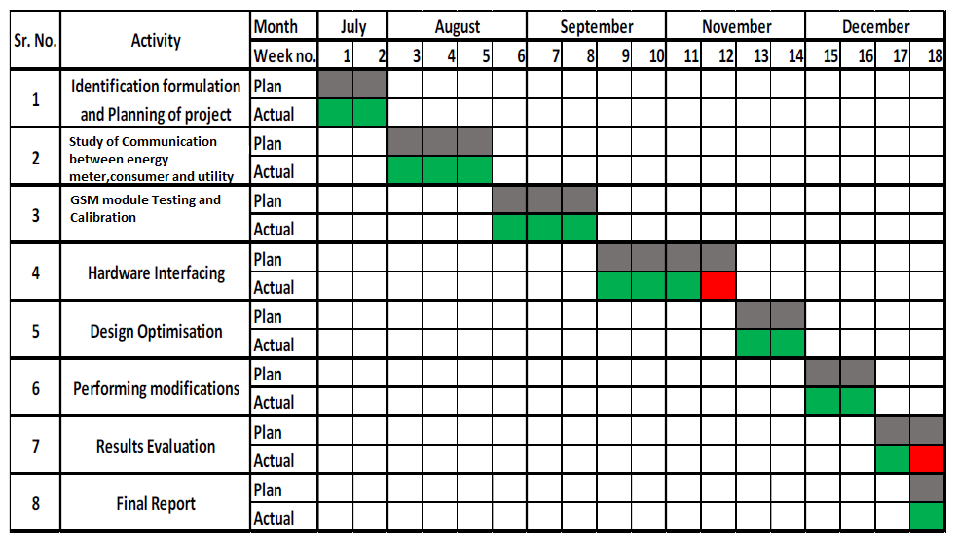

**Project Outcomes & Individual Roles**

* Here, you need to list the final outcomes/ products/ systems/ deliverables of your capstone project.
* The individual team member role must also be clearly specified in this section.

**Course Subjects**

* In this section, you need to list the course subjects that will be used (in the form of conceptual knowledge or practical skills sets) during the successful execution of your capstone project.

**References**

**Formatting Guidelines**

* Project Report Type:  Transparencies and tape bound
* Number of Copies: 1 per Project group (Max pages 15)
* Running text should be justified, figures and tables center aligned, no space before full stop etc.
* Use **passive voice** in text.
* Paper Size (orientation): A4 (portrait)
* Margins: 1” top / bottom / right and 1.5” left
* Font Type: Times New Roman
* Font Size: 16 bold for Section names, 14 bold for headings and 12 for normal text
* Line Spacing: 1.5 throughout
* Page Numbering:  Bottom center of page in the format – Page 1 of N
* All table and figure captions in size 10 sentence case, table captions on top and figure captions below the figure.
* All figures and tables quoted in the text with explanation.
* No figures and equations should be copied. Please use **smartdraw/ visio for figures and Mathtype** for equations.
* References (The listing of references should be typed 2 spaces below the heading “REFERENCES” in alphabetical order in single spacing left – justified.  It should be numbered consecutively (in square [ ] brackets, throughout the text and should be collected together in the reference list at the end of the report. The references should be numbered in the order they are used in the text. The name of the author/authors should be immediately followed by the year and other details). References should not be cited from Blogs, Twitter etc. but should refer to good Journal or Conference papers. Typical examples of the references are given below:

**REFERENCES**

[1] Ariponnammal, S. and Natarajan, S. (1994) ‘Transport Phonomena of SmSel – X Asx’, Pramana – Journal of Physics Vol.42, No.1, pp.421-425.

[2] Anderson T. , Peterson L., Shenker S., Turner J.(2005).Overcoming the Internet impasse through virtualization. IEEE Computer, 38(4):34-41.

[3] W. Zeng, H. Yu, C. Lin. (2013, Dec 19). Multimedia Security Technologies for Digital Rights Management [Online]. Available: http://goo.gl/xQ6doi